Opening an INC

Objective
Opening an INC via ServiceNow and ServicePortal

Responsibility Definition
Any employee can open a ticket via ServicePortal.
- Only IT analysts can open tickets via ServiceNow.

Step by Step – ServicePortal
- When accessing the Contoso intranet (Contoso Intranet | Home)
- Click on “My Essentials” and then on “ ServiceNow.
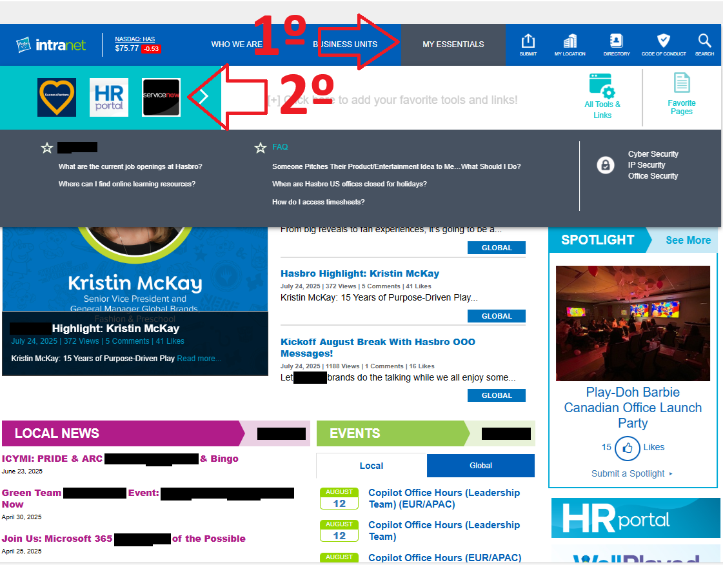
- On the next screen, click on “Tech Support”:
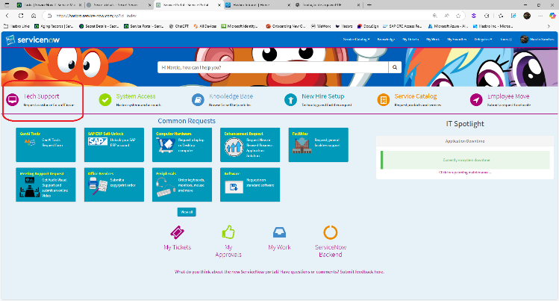
- On the “Tech Support” screen:
- Fill in the form with a subject.
- Provide a brief description of the problem.
- Click the “Submit” button.
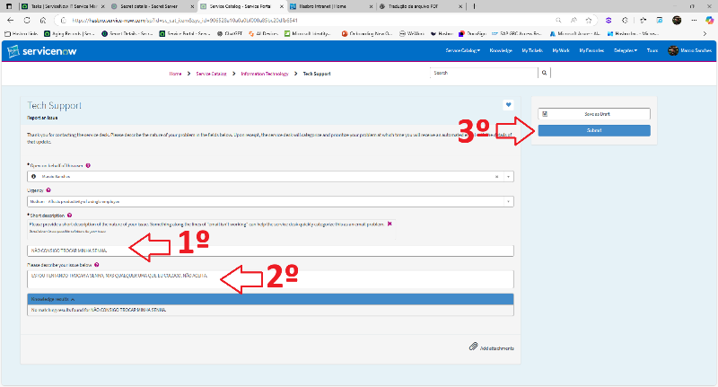
- On the last screen, you will see the ticket progress as well as its number:
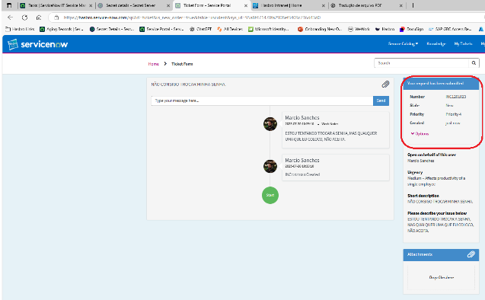

Step by Step – ServiceNow
- Access the ServiceNow site (Tickets and Incidents | ServiceNow). Click on the Incidents list on the left and the “New” button on the right:
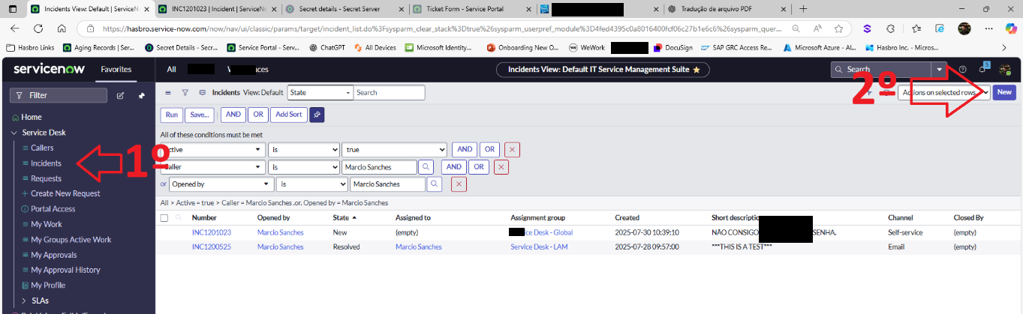
- On the next screen, fill in all the options:
- “Caller”: The employee who needs support
- “Channel”: Always use “E-Mail”
- Assignment Group: Select the group that handles the issue. If it is the IT Analyst, the group is “Service Desk (BR) - LAM”
- Assigned to: If you set the Group as “Service Desk (BR) - LAM” in step 3 – Select your name.
- Urgency: Must ALWAYS remain at Medium, unless it is a truly critical error.
- Configuration item: Select the program that is experiencing the issue. If it is not in the list, select “Other”.
- Provide a subject and a brief description of the problem. ALWAYS write in English if the assignment group is not “Service Desk (BR) – LAM”.
- Finally, click “Submit”.
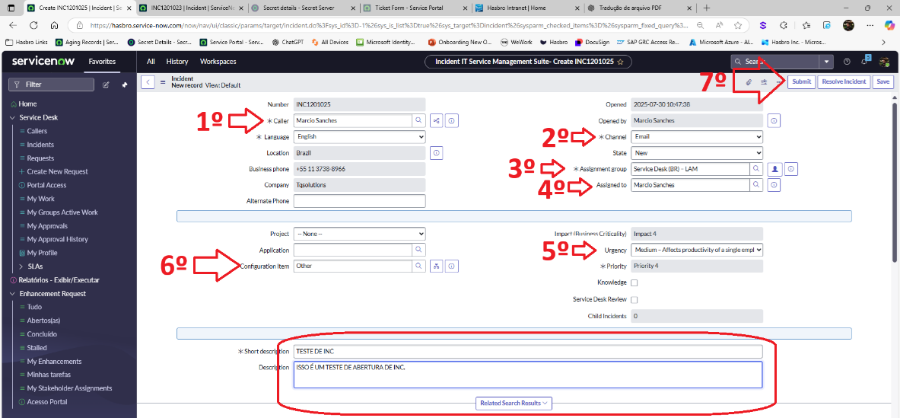

Version History
Author | Version | Date | Change Description
IT Team | 1.0 | 30/07/2025 | Creation
Lucas Souza | 1.1 | Jun/2026 | Document standardization

